DAY 22: Create Alerts and Dashboards in Kibana (Part 4)
Summary: <place holder>

I’m using a little trick here because I know the payload file name. I’m focusing on related events to reduce noise from other events and identify important fields for further investigate, so I search for the term svchost-vinh.exe in the Kibana search bar.
* Note: I don’t recommend searching for terms directly in the search bar like this, because this query is not optimized. In a larger SIEM system, it can make searches slower and consume more system resources.
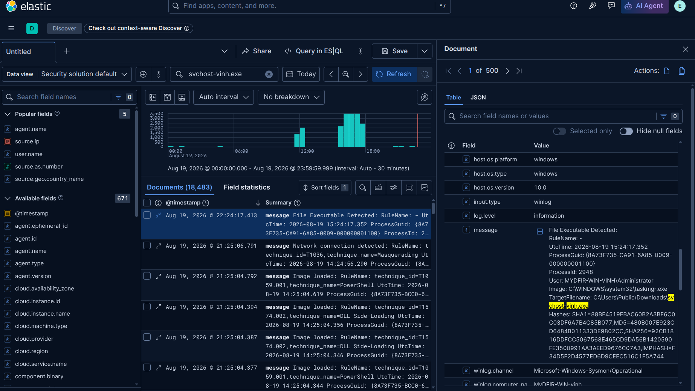
Figure 1: search by file name
At a glance, we can see a lot of important information on the message field, including File name, Hashes, User who runs that file,... At the bottom of the message field that has winlog.channel field provide name of the channel record this event, in this case is the Sysmon I configured from previous days.
I want to fine-tune the query in more details and focus on the process creation event, because this is the entry point for all later malicious activities.
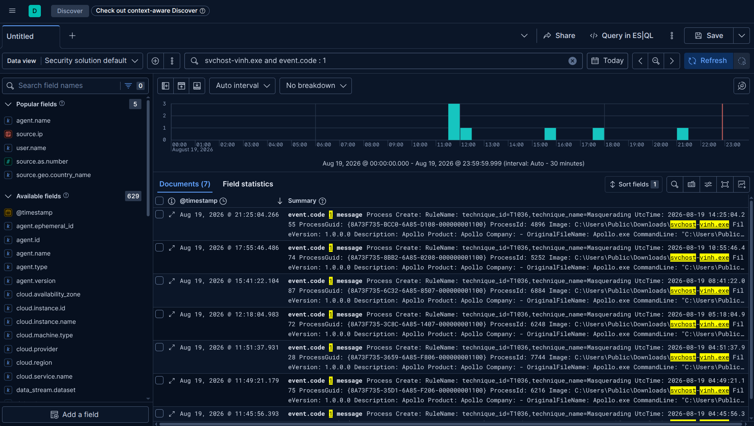
Figure 2: Focus on process creation events
As shown in Figure 2, we only have seven matching documents. This helps filter out noise from unrelated events, making the investigation easier.
When we write a long conditional query without parentheses to specify the order of operations, the conditions connected by AND operators are evaluated sequentially left to right. The OR operator acts as a boundary to split each (AND) block.
Collect IOCs from related events, I have constructed the complete query:

svchost-vinh.exe and event.code : 1 and winlog.event_data.Hashes : "SHA1=88BF4519FBAC60B2A3BF6C0C03DF6A7B4C85B077,MD5=480B007E923CD6484B011333DE9802CC,SHA256=92CB1816DDFCC5067568E465CD9DA56B1420590FE3500991AA3AEED9676C07A3,IMPHASH=F34D5F2D4577ED6D9CEEC516C1F5A744" or winlog.event_data.OriginalFileName : "Apollo.exe" (1)

Similar to:

(svchost-vinh.exe and event.code : 1 and winlog.event_data.Hashes : "SHA1=88BF4519FBAC60B2A3BF6C0C03DF6A7B4C85B077,MD5=480B007E923CD6484B011333DE9802CC,SHA256=92CB1816DDFCC5067568E465CD9DA56B1420590FE3500991AA3AEED9676C07A3,IMPHASH=F34D5F2D4577ED6D9CEEC516C1F5A744") or (winlog.event_data.OriginalFileName : "Apollo.exe")

=> Matching either clause is sufficient
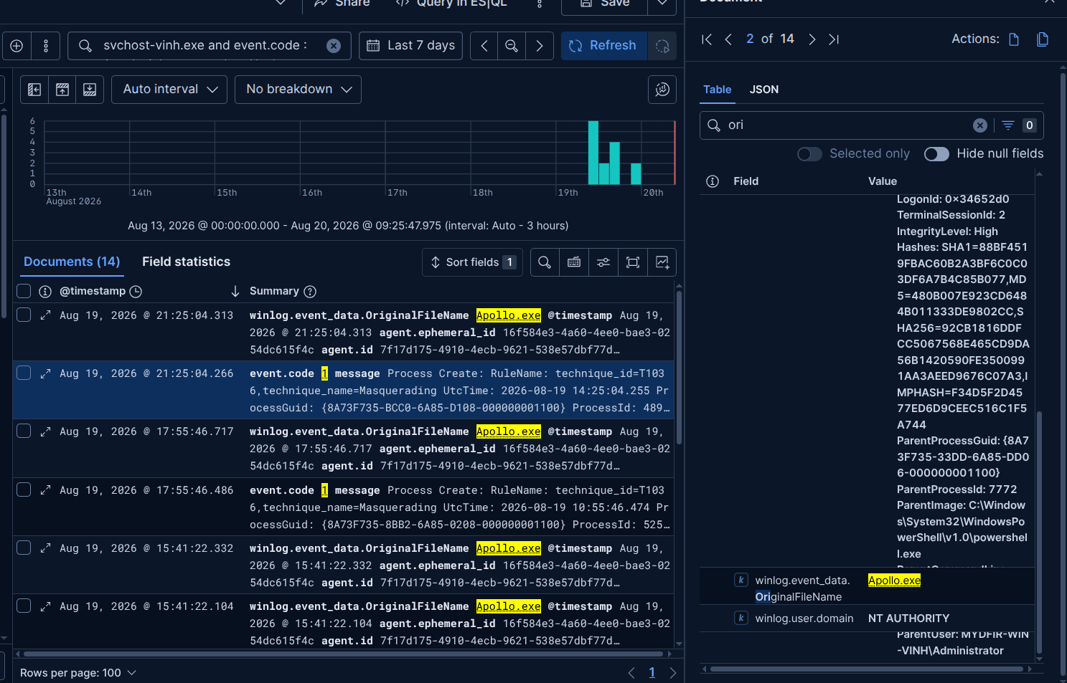
Figure 3: Results from the (1) query

After adding parenthesis if different position, the query results are also different. For example in this case, I want to take correctly all process creation event related to the malicious file:

event.code : 1 and (winlog.event_data.Hashes : "SHA1=88BF4519FBAC60B2A3BF6C0C03DF6A7B4C85B077,MD5=480B007E923CD6484B011333DE9802CC,SHA256=92CB1816DDFCC5067568E465CD9DA56B1420590FE3500991AA3AEED9676C07A3,IMPHASH=F34D5F2D4577ED6D9CEEC516C1F5A744" or winlog.event_data.OriginalFileName : "Apollo.exe")

* Note: remove the term svchost-vinh.exe to keep it shorter

The number of results returned will be lower because the conditions in (1) don't have parentheses, so it will match another event code.

Create a detection rule for alerting Apollo C2 traffic:
The required fields are considered to add into a detection rule:
- host.name
- message
- winlog.event_data.CommandLine
- winlog.event_data.Image (an Elastic Common Schema (ECS) field path used in SIEM platforms like Elasticsearch and Splunk. It records the full file path of the executable program that started a process during a Windows event log or Sysmon activity)
- winlog.event_data.ParentCommandLine

- winlog.event_data.ParentImage
- winlog.event_data.ParentProcessGuid
- winlog.event_data.ProcessGuid
- winlog.event_data.User
- winlog.event_data.CurrentDirectory

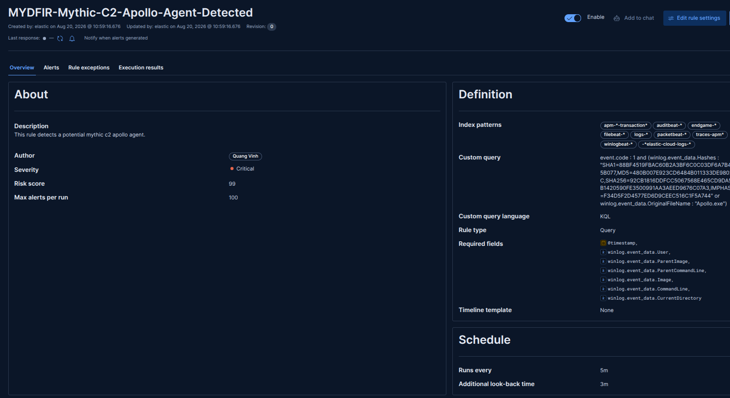
Figure 4: A rule detects Apollo C2 traffic

Similar to the SSH authentication dashboard, I also create a dashboard for RDP authentication events. This dashboard displays suspicious activities which provides an overview about Windows system status.
I intended to create a dashboard with three panels, including: process creation, Network connection detected and Antivirus real-time protection configuration has changed.
Let’s go to create panels one-by-one:

- Event ID: 1 - Process Creates. Look for Powershell, cmd, rundll32
The query I use for Event ID 1 is:

event.code : 1 and (powershell or cmd or rundll32) and event.provider: "Microsoft-Windows-Sysmon"
Before paste it to my panel, I will search in Discover tab to verify whether it working correctly:
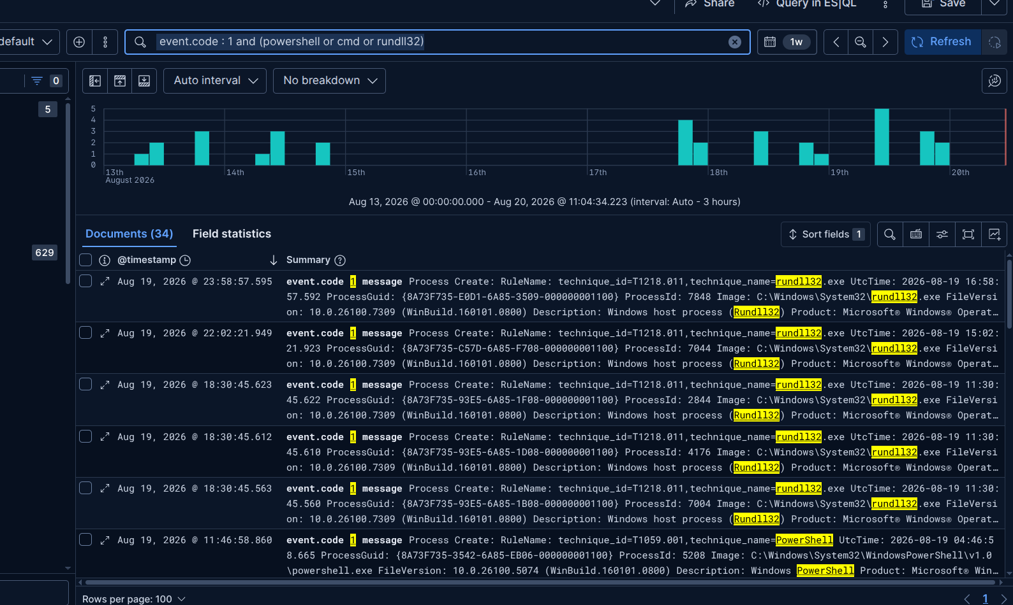
Figure 5: Search related to process creation event
Go to the Visualization tab to create the panel as table:

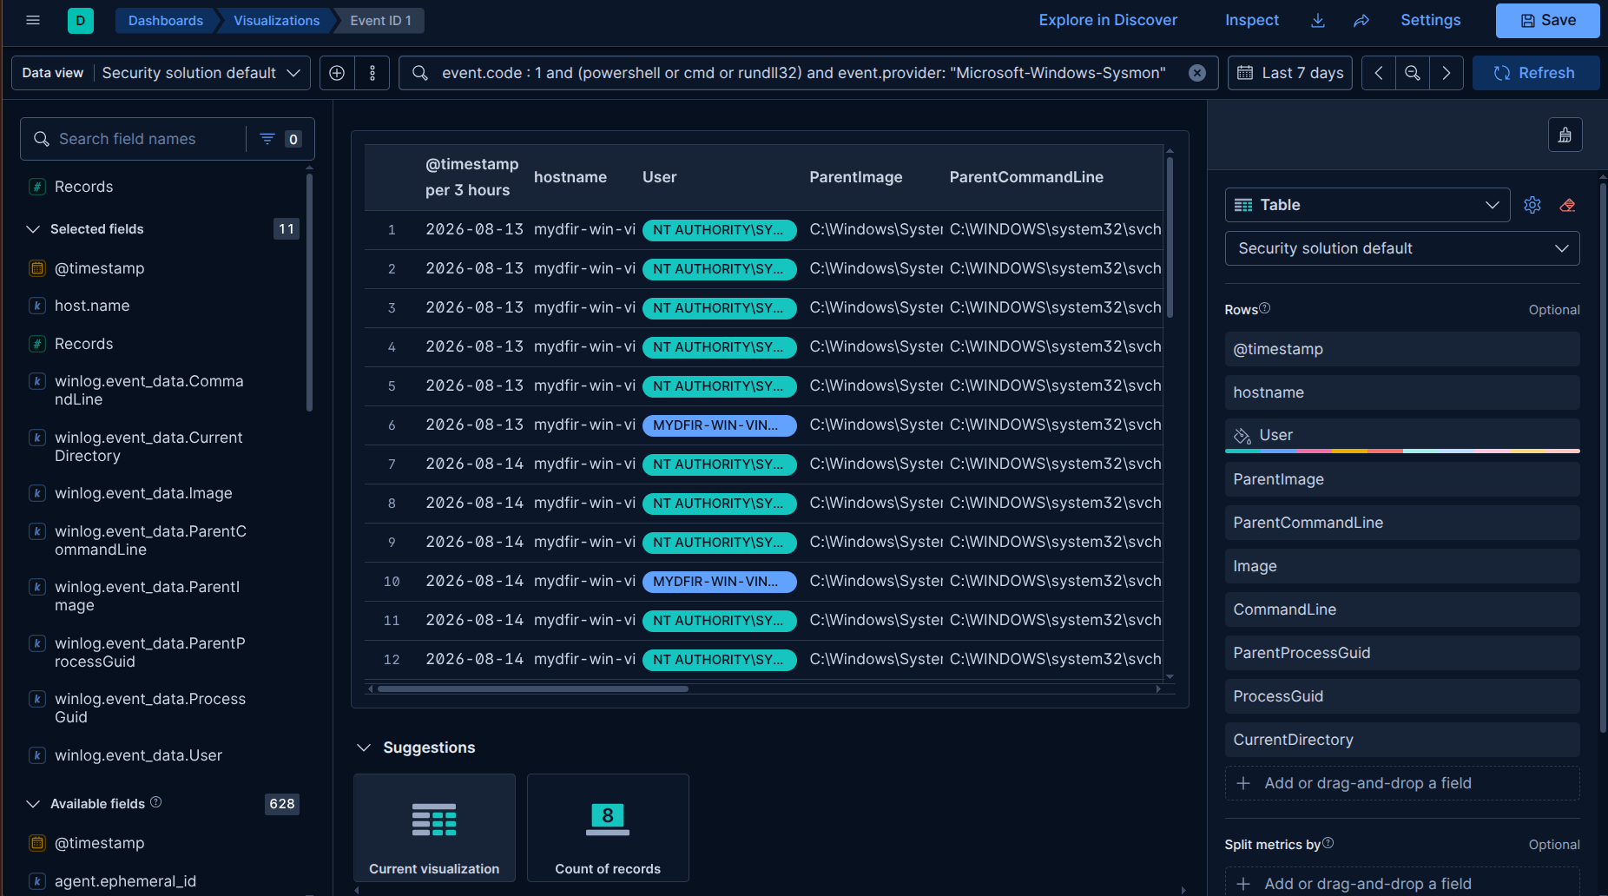
Figure 6: Process creation panel
The columns displayed in the table include: timestamp, hostname, User, ParentImage, ParentCommandLine, Image, CommandLine, ParentProcessGuid, ProcessGuid, CurrentDirectory.

- Event ID: 3 - Network connection (external) any processes INITIATING a network connection outbound.
The query I use for Event ID 3 is:

event.code : 3 and event.provider: "Microsoft-Windows-Sysmon" and winlog.event_data.Initiated: true
Four main columns will be displayed in the table include:
- winlog.event_data.Image
- winlog.event_data.DestinationIp
- winlog.event_data.SourceIp
- winlog.event_data.DestinationPort
Because above query still returns a lot of noise from unrelated events, so I can fine-tune it further based on specific details of my situation:

event.code : "3" and event.provider : "Microsoft-Windows-Sysmon" and winlog.event_data.Initiated : true and not winlog.event_data.Image : (*MpDefenderCoreService.exe or "C:\ProgramData\Microsoft\Windows Defender\Platform\4.18.26070.9-0\MsMpEng.exe" or "C:\Program Files\Elastic\Agent\elastic-agent.exe" or "C:\Program Files (x86)\Microsoft\Edge\Application\msedge.exe")
In the adjusted query, I add NOT operator with “*” wildcard to exclude any events associated with known benign software, such as MpDefenderCoreService.exe, MsMpEng.exe, elastic-agent.exe and msedge.exe.

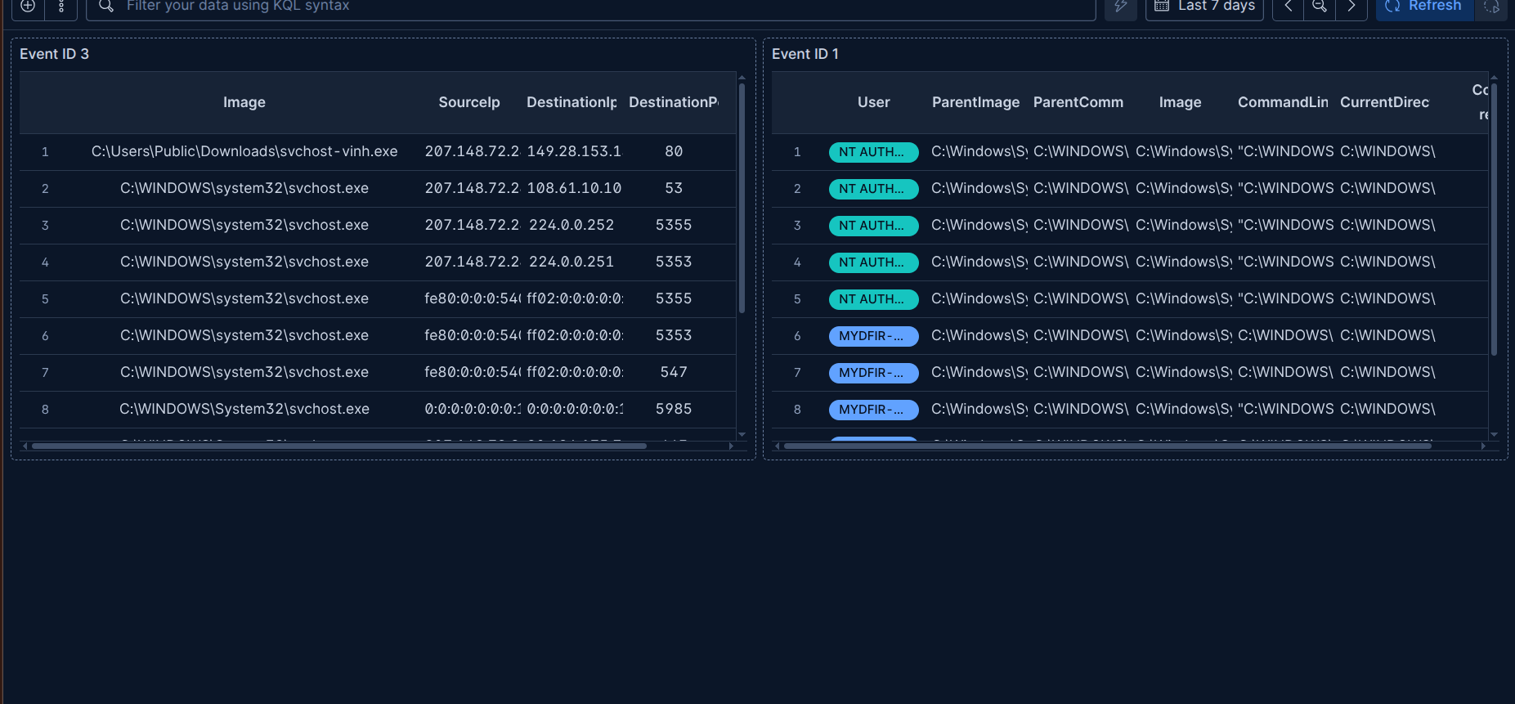
Figure 7: Created successfully panels for Event ID 1 and 3

- Event ID: 5001 - Windows Defender disabled
The query I use for Event ID 5001 is:

event.code : 5001 and Microsoft-Windows-Windows Defender

In summary, we have the following 3 table panels in the RDP dashboard:
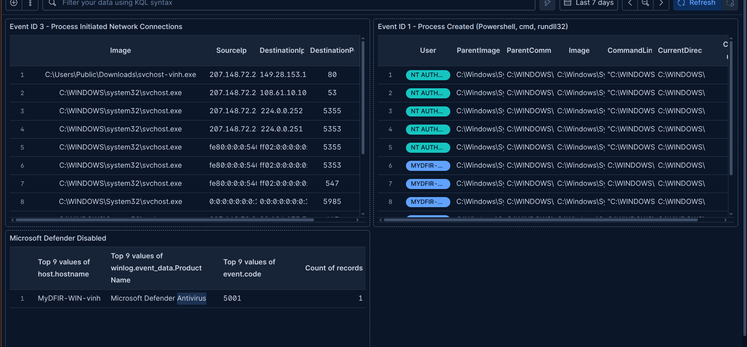
Figure 8: Complete dashboard for suspicious activities on Windows
REFERENCES:
[1] Kibana dashboard guidline: https://www.elastic.co/docs/extend/integrations/dashboard-guidelines

